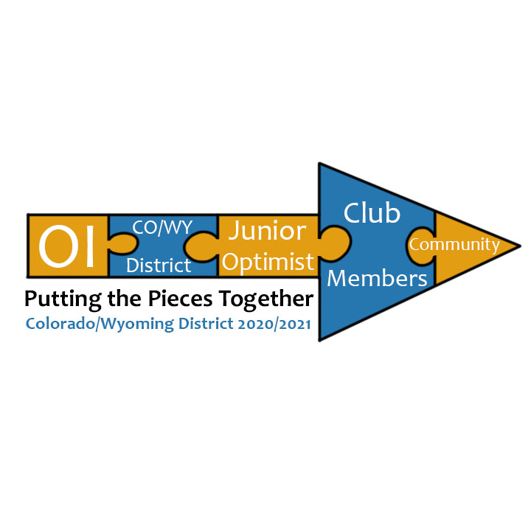
Colorado/Wyoming District
Virtual 2nd Quarter Conference & Board Meeting
Saturday, February 6, 2021
9:00 a.m. To 12:30 p.m.

$_________ Regular Registration: $10 per person (Received from January 5 to February 5th)

$_________ (Optional) If you would like to donate for Autism Sensory Kit Pack @ $20.00

$_________ (Optional) “Gifts of Love” Fundraiser Baskets drawing @ $1.00 per ticket
Unlimited entry, must be present at drawing to win at 12:15
Total $_______

Name Optimist 1: _____________________________________________________________________________

Mailing Address: ______________________________________________________________________________

City: ____________________________________________________________Zip: _________________________

Daytime Telephone Number: __________________________First Timer? ________________________________

Optimist 1 Club: ____________________________________Club Position: _______________________________

EMAIL: _______________________________________________________________________________________

Name Optimist 2: ______________________________________________________________________________

Mailing Address: _______________________________________________________________________________

City: ____________________________________________________________Zip: __________________________

Daytime Telephone Number: ___________________________First Timer? ________________________________

Optimist 2 Club: _____________________________________Club Position: _______________________________

YOU MAY PAY ONLINE AT THE COLORADO/WYOMING OPTIMIST WEBSITE
www.optimistcowy.org/conferences
If paying by check: Make check payable to: Colorado/Wyoming Optimists
If using USPS for your registration/payment, allow 3 calendar days.
***EITHER WAY THAT YOU PAY, PLEASE SEND YOUR REGISTRATION FORM TO:***
Carol Brown, 4748 N. Splendid Circle, Colorado Springs, CO 80917
Phone: 719-502-0753 or email form to cbrown30@hotmail.com

