
COLORADO-WYOMING DISTRICT
OPTIMIST GOLF SCRAMBLE

FUNDRAISER FOR COLORADO-WYOMING DISTRICT
OPTIMIST JUNIOR GOLF PROGRAM

HELP US SEND 70 JUNIOR GOLFERS TO THE
2023 OPTIMIST INTERNATIONAL JUNIOR GOLF
CHAMPIONSHIPS AT TRUMP NATIONAL DORAL RESORT - MIAMI

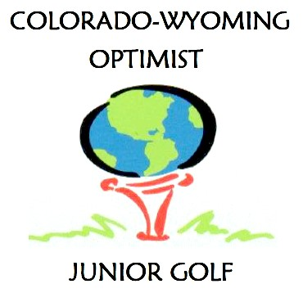

WHERE: Meadow Hills Golf Course, 3609 Dawson St, Aurora CO
WHEN: Thursday, May 25th – tee times starting at 7:30 am
PRICE: $ 150 per player
Includes:
Green Fee and Cart
Lunch
Team Prizes
Closest to the pin on all par 3’s
Longest drives (men’s and women’s)
Longest putt
Donation to CO-WY District Junior Golf

If you have a foursome, you can enter as a team, or we will establish teams based on individual entries.

Please make your $ 150 checks payable to “Optimist Junior Golf” or to “Optimist International Foundation” if you would like a tax deduction from a 501 (c) (3) charitable organization and mail the checks and this entry form to:
Joe Marci
4173 S Rosemary Way
Denver CO 80237

Name:______________________________________________ Email:_________________________

Address:____________________________________________ Phone:________________________

____________________________________________ ZIP:________________

Optimist Club:_______________________________________

Other Team Members:

Name:______________________________________________

Name:______________________________________________

Name:______________________________________________

We need the support of all Optimists and their friends to make this a successful tournament. There will be a silent auction during lunch for some valuable items donated to Optimist Junior Golf.

If you have any questions, please call Joe Marci at 303-847-7844 or Bob Meyer at 303-919-4532.

